**UNIT-IV: Transport Layer**

The Transport Layer is one of the key layers of the OSI (Open Systems Interconnection) model and the TCP/IP (Transmission Control Protocol/Internet Protocol) suite. Its primary function is to provide reliable, end-to-end communication and data transfer between applications running on different devices across a network. The transport layer ensures that data is delivered accurately, in the correct order, and without errors or loss.

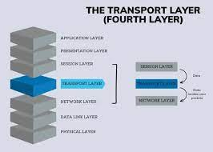

**The main protocols associated with the Transport Layer are:**

1. **Transmission Control Protocol (TCP):** TCP is a connection-oriented protocol that provides reliable, error-checked data transmission. It establishes a virtual connection between the sender and receiver before transmitting data. TCP guarantees that data packets are delivered in the order they were sent and handles retransmission of lost packets to ensure the successful delivery of data. It also implements flow control to manage the rate at which data is sent to prevent overwhelming the receiver.
2. **User Datagram Protocol (UDP):** UDP is a connectionless protocol that offers unreliable data transmission. Unlike TCP, UDP does not establish a virtual connection before sending data. It simply sends data packets to the destination without guaranteeing their delivery or order. This makes UDP faster and more suitable for applications where real-time data transmission is essential, such as video streaming and online gaming. However, UDP does not provide error-checking or retransmission of lost packets.

**Transport Layer Design Issues**

Designing the Transport Layer involves addressing various issues to ensure efficient and reliable data transmission between communicating hosts. Some of the key design issues for the Transport Layer include:

1. **Reliability:** One of the primary concerns of the Transport Layer is to provide reliable data delivery. It involves mechanisms to ensure that data packets are delivered without errors, in the correct order, and without loss. This requires error detection, error correction, and retransmission of lost or corrupted packets. Protocols like TCP are designed to offer reliable data transmission.
2. **Flow Control:** To prevent the sender from overwhelming the receiver with data, flow control mechanisms are implemented. Flow control ensures that data is transmitted at a rate the receiver can handle, preventing data loss due to buffer overflows. TCP uses a sliding window mechanism for flow control.
3. **Congestion Control:** Congestion control manages the data flow to avoid network congestion. It regulates the rate of data transmission based on the network's capacity and traffic conditions. TCP employs various congestion control algorithms, such as TCP Reno and TCP Cubic, to adapt the sending rate dynamically.
4. **Connection Establishment and Termination:** For connection-oriented protocols like TCP, establishing and terminating connections between communicating hosts is a critical design consideration. The three-way handshake is typically used to establish a connection, and a four-way handshake is used to terminate it.
5. **Header Overhead:** The Transport Layer adds its own header information to the data received from the upper layers. Minimizing this header overhead is essential to optimize data transmission efficiency and reduce network utilization.
6. **Ordering of Data:** The Transport Layer ensures that data packets are delivered to the receiving application in the order they were sent by the sender. This is crucial for applications that require data to be processed sequentially.
7. **Multiplexing and Demultiplexing**: The Transport Layer allows multiple applications to share the same network connection through multiplexing. It assigns identifiers (e.g., port numbers) to different applications, and at the receiving end, demultiplexing is done to direct the data to the appropriate application based on these identifiers.
8. **Segmentation and Reassembly:** Data sent by applications can be larger than the maximum transmission unit (MTU) supported by the network. The Transport Layer breaks this data into smaller segments for transmission and reassembles them at the receiving end.
9. **Service Differentiation**: Quality of Service (QoS) mechanisms may be implemented in the Transport Layer to prioritize certain types of traffic over others. This ensures that critical applications receive appropriate resources and performance guarantees.
10. **Security:** Transport Layer protocols may also incorporate security features, such as encryption and authentication, to protect the data being transmitted from unauthorized access and tampering.

**Connection Establishment**

Connection establishment is a critical process in the Transport Layer, especially for connection-oriented protocols like TCP. It involves a series of steps to set up a reliable communication channel (connection) between two communicating devices before data can be exchanged. The most commonly used method for connection establishment is the three-way handshake, which is a three-step process. Here's how it works:

* **Step 1 - SYN (Synchronize):** The process begins when the client (initiator) sends a SYN packet to the server (receiver). The SYN packet contains a sequence number chosen by the client to initiate the connection. This packet indicates the client's intention to establish a connection.
* **Step 2 - SYN-ACK (Synchronize-Acknowledge)**: Upon receiving the SYN packet, the server responds with a SYN-ACK packet. The SYN-ACK packet contains its own sequence number and an acknowledgment number that confirms receipt of the client's SYN packet. Additionally, the server also sends an acknowledgment (ACK) for the client's sequence number plus one, indicating its readiness to establish the connection.
* **Step 3 - ACK (Acknowledge):** Finally, the client acknowledges the server's response by sending an ACK packet. This ACK packet contains the server's sequence number plus one, confirming the server's readiness to accept data from the client.

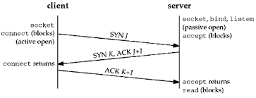

At this point, the three-way handshake is complete, and the connection is established between the client and the server. Both parties have exchanged initial sequence numbers and agreed on the sequence number to be used for subsequent data exchange. Now, they can begin transmitting data back and forth reliably and in the correct order.

The three-way handshake helps ensure that both the client and server are aware of each other's readiness to communicate and establishes initial sequence numbers to keep track of the data exchanged during the connection.

Once the connection is established, data can be transmitted in both directions until one of the parties decides to terminate the connection. Connection termination typically involves a four-way handshake, where both the client and the server exchange FIN (Finish) and ACK packets to close the connection gracefully.

**Connection Termination**

Connection termination is the process of closing a communication channel (connection) between two devices that have been previously established for data exchange. In connection-oriented protocols like TCP, a four-way handshake is used for graceful connection termination. This ensures that all data is successfully transmitted and received before the connection is closed. Here's how the four-way handshake for connection termination works:

1. **Step 1 - Client Sends FIN (Finish):** The client, which initiates the connection termination, sends a FIN packet to the server. The FIN packet indicates that the client has no more data to send and wants to close the connection.
2. **Step 2 - Server Sends ACK (Acknowledge)**: Upon receiving the FIN packet, the server sends an ACK packet back to the client to acknowledge that it received the FIN packet.
3. **Step 3 - Server Sends FIN (Finish)**: After sending the ACK packet, the server also initiates its connection termination by sending a FIN packet to the client. This packet indicates that the server has no more data to send and wishes to close its end of the connection
4. **Step 4 - Client Sends ACK (Acknowledge):** Upon receiving the server's FIN packet, the client responds with an ACK packet to acknowledge that it received the FIN packet. The connection is now fully closed from the client's side.

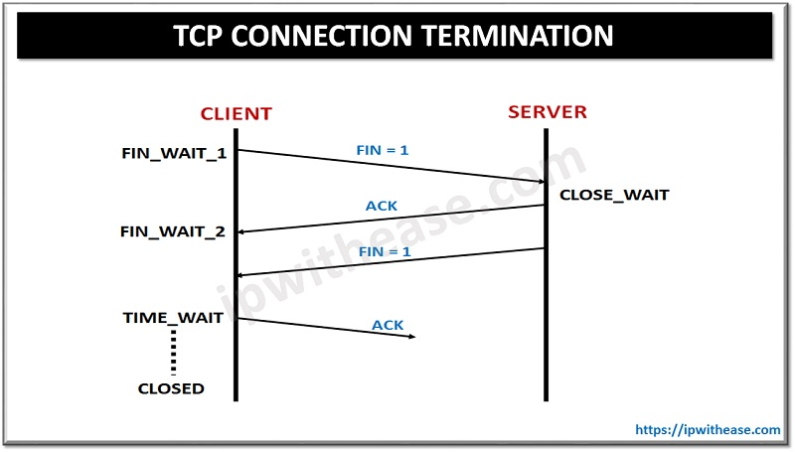

After the four-way handshake is completed, the connection is successfully terminated, and both the client and server are aware that the communication channel is closed. Each party has sent and received ACK packets for the FIN packets, ensuring that all remaining data has been transmitted and received before the connection closure.

It's important to note that TCP provides reliable and ordered data delivery. During the connection termination process, TCP ensures that any remaining data in transit is delivered to the receiving end before the connection is closed. This guarantees that no data is lost or left unacknowledged during the termination process.

**In contrast,** UDP, being connectionless, does not involve a formal connection termination process. Since there is no connection state to maintain, UDP simply stops sending and receiving data once the applications decide to end the data exchange.

**Transport Datagram Protocols**

As of my last update in September 2021, there is no specific protocol called "Transport Datagram Protocol" known by that exact name. It's possible that the term was used in a specific context or might refer to a general concept.

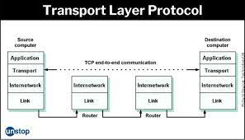

The two main transport layer protocols that are commonly used are the Transmission Control Protocol (TCP) and User Datagram Protocol (UDP), as I mentioned in the previous response. However, if you are referring to "Transport Datagram Protocol" as a generalized concept, it might be used to describe any transport layer protocol that uses datagrams, which are self-contained units of data.

UDP is an example of a transport protocol that uses datagrams. In UDP, data is sent in individual packets known as datagrams, and each datagram is independent of the others. It means that UDP does not establish a connection before transmitting data and treats each packet as a separate entity, providing a connectionless communication model.

Datagram-based transport protocols are often used in scenarios where a low-overhead and minimal setup are required, and occasional data loss is acceptable. Real-time applications such as VoIP, video streaming, and online gaming commonly use UDP due to its low latency and reduced processing overhead compared to TCP. However, it is essential to consider that UDP lacks the reliability and error recovery mechanisms present in TCP.

If "Transport Datagram Protocol" refers to a specific protocol that has emerged after my last update, I apologize for not having information about it. Technologies and protocols may continue to evolve, and it's possible that new developments have occurred since my knowledge cutoff date.

**User Datagram Protocols**

Apologies for any confusion in my previous responses. To clarify, it seems there was a slight typo in your query. The correct term is "User Datagram Protocol" (UDP), not "Transport Datagram Protocol."

**User Datagram Protocol (UDP):**

UDP is one of the core transport layer protocols in the TCP/IP suite, providing a connectionless, lightweight, and unreliable data delivery service. Unlike TCP, UDP does not establish a connection before transmitting data and does not guarantee reliable delivery or ordering of data packets.

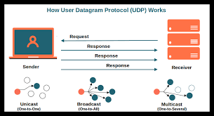

Key characteristics of UDP:

1. **Connectionless:** UDP is a connectionless protocol, which means that it does not require a prior connection setup between the sender and receiver before data transmission. Each UDP packet (datagram) is treated as an independent unit and is addressed to the destination.
2. **Unreliable:** UDP does not offer reliability mechanisms like error-checking, acknowledgment of data receipt, or retransmission of lost packets. This lack of reliability is intentional to keep UDP lightweight and efficient.
3. **Low Overhead:** UDP has a smaller header compared to TCP, resulting in lower overhead for transmitted data. This makes UDP more suitable for applications where minimal delay is critical.
4. **Fast Data Transmission**: Due to its connectionless nature and lack of extensive error-handling mechanisms, UDP can achieve lower latency compared to TCP, making it appropriate for real-time applications such as VoIP, video streaming, and online gaming.
5. **No Flow Control:** UDP does not implement flow control mechanisms to manage the rate of data transmission. It allows the sender to transmit data at its maximum rate without regulating the receiver's capacity, which can lead to potential packet loss in congested networks.

UDP is suitable for applications that prioritize low latency and real-time data delivery over data integrity. However, because of its lack of reliability, it is crucial for the application using UDP to handle any necessary error recovery and packet ordering if required.

**delve into the differences between the Transport Control Protocol (TCP) and User Datagram Protocol (UDP)**

**TCP (Transmission Control Protocol):**

1. **Reliability:** TCP is a connection-oriented protocol that provides reliable data delivery. It guarantees that data packets are delivered without errors, in the correct order, and without loss. If any packets are lost during transmission, TCP automatically retransmits them to ensure successful delivery.
2. **Connection-oriented**: TCP establishes a virtual connection between the sender and receiver before transmitting data. This connection remains active throughout the duration of the data exchange, and both parties must perform a handshake to establish and terminate the connection.
3. **Flow Control:** TCP implements flow control mechanisms to manage the rate at which data is sent. It prevents the sender from overwhelming the receiver with data by using a sliding window approach, ensuring efficient data transmission.
4. **Ordering of Data**: TCP ensures that data packets are delivered in the same order they were sent. It reorders out-of-sequence packets before passing them to the application layer.
5. **Packet Header Overhead:** TCP includes relatively larger header information, including sequence numbers, acknowledgment numbers, and other control fields. This adds some overhead to the transmitted data.
6. **Applications**: TCP is suitable for applications that require reliable and ordered data delivery, such as web browsing, file transfer, email, and any other application where data integrity is critical.

**UDP (User Datagram Protocol):**

1. **Unreliable**: UDP is a connectionless protocol that does not guarantee reliable data delivery. It does not perform error-checking or retransmission of lost packets. Packets sent via UDP may arrive out of order, be duplicated, or even be dropped without any notification.
2. **Connectionless:** UDP does not establish a connection before transmitting data. Each packet is treated as an independent entity and can be sent to the destination without any prior setup.
3. **No Flow Control**: UDP does not have built-in flow control mechanisms. The sender can transmit data at its maximum rate, regardless of the receiver's capacity. This means that UDP may lead to congestion and packet loss in a congested network.
4. **Ordering of Data:** UDP does not guarantee the ordering of data packets. It is the responsibility of the application layer to handle any reordering required.
5. **Packet Header Overhead:** UDP includes a smaller header compared to TCP, resulting in less overhead for transmitted data.
6. **Applications:** UDP is suitable for applications where real-time data transmission is crucial, such as VoIP (Voice over Internet Protocol), video streaming, online gaming, and other applications where low latency is more important than data integrity.

